Angular JS

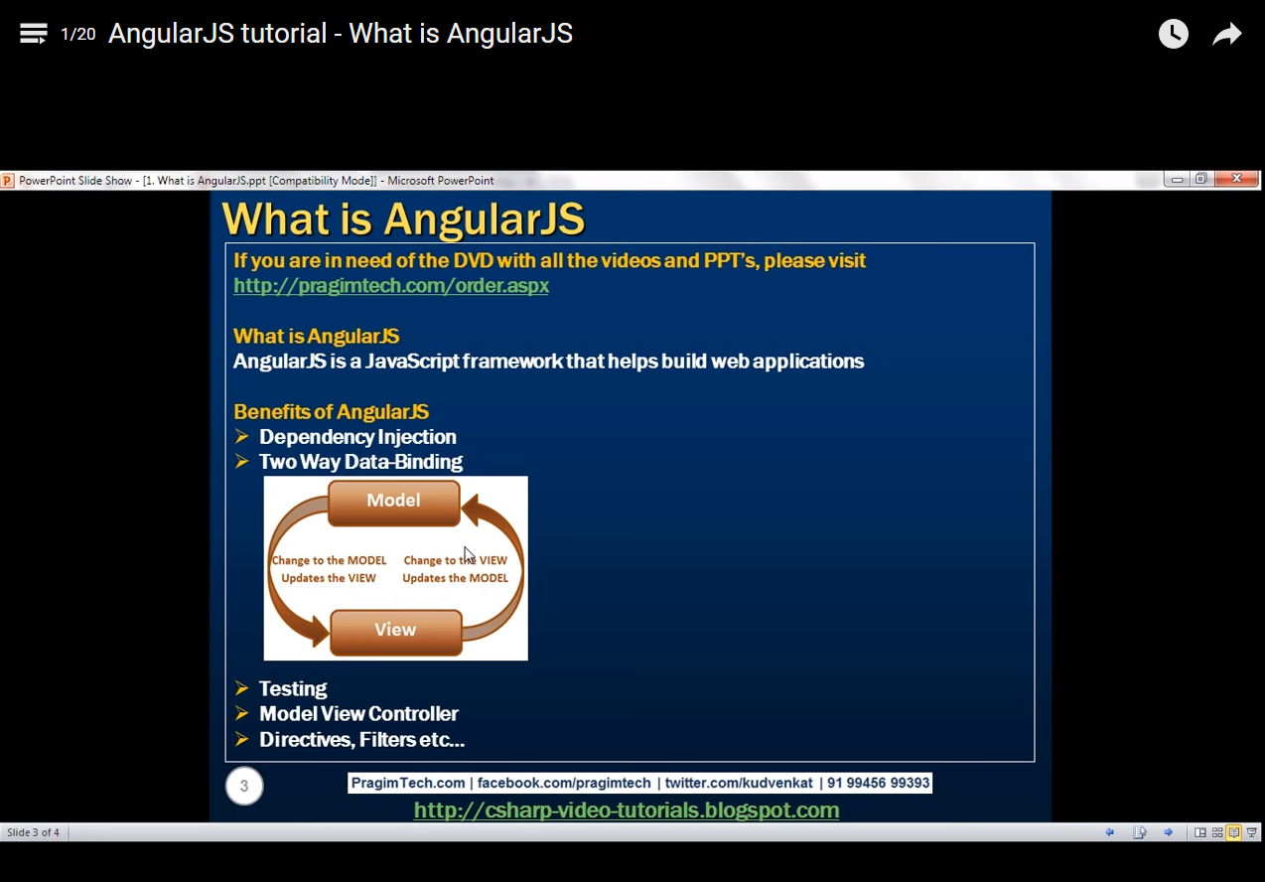

https://www.madewithangular.com - This website contains the list of sites developed using Angular JS

Benefit: Dependency injection, two way data binding - model and view sync, Model will change if view changes and vice versa, Unit and End to end testing support, Model view controller

Directives – controlling the behavior of DOM elements

Modules, Routes has to be discussed

ng-app - Starting point of angular js application, then angular js boot strap will start work once this directive is found in the application. Entire <Body> section will be handled by Angular.

{{ }} – called binding expressions

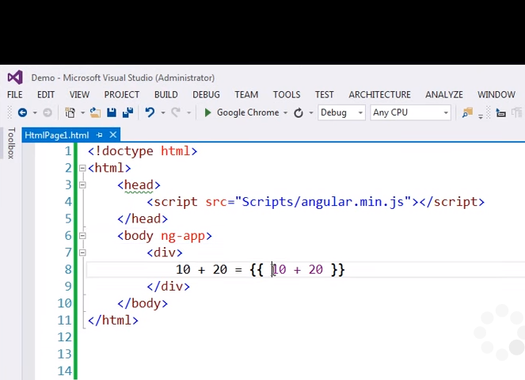

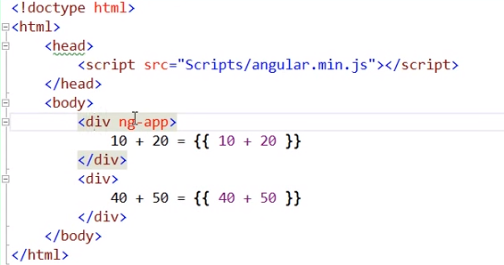

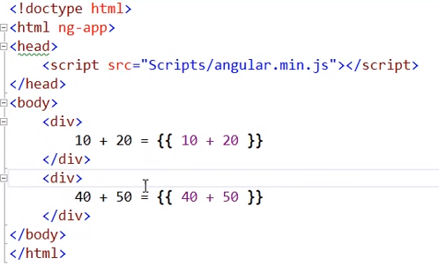

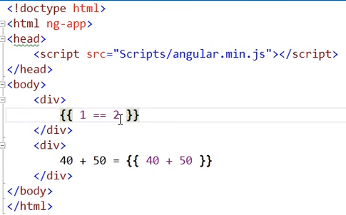

Out : False

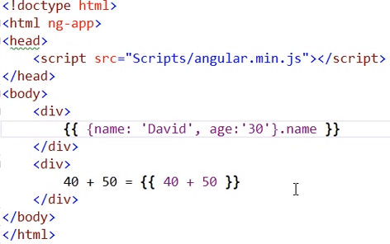

We can use POJO objects in binding expression

Out: David.

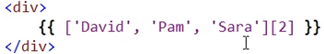

We can use Array

Out: Sara

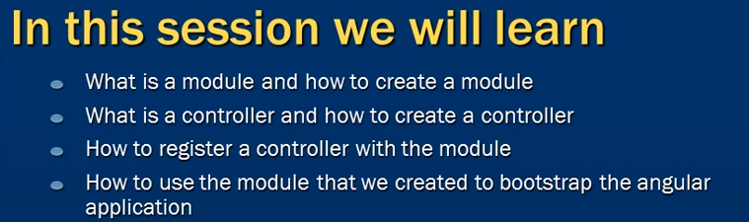

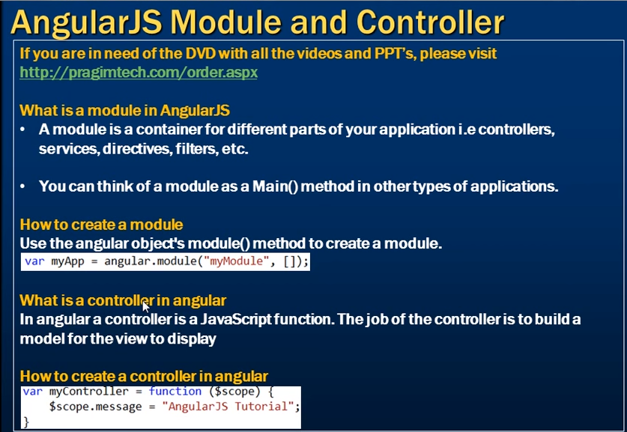

$Scope is the angular object that is passed to this controller function by the angular framework automatically

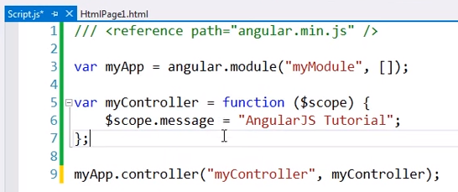

Other way to define controller,

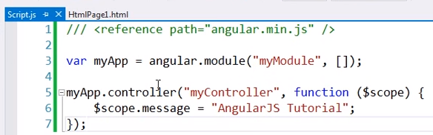

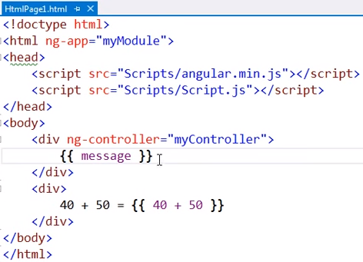

Out : AngularJS Tutorial

Outside of div ng-controller, message object will not available.

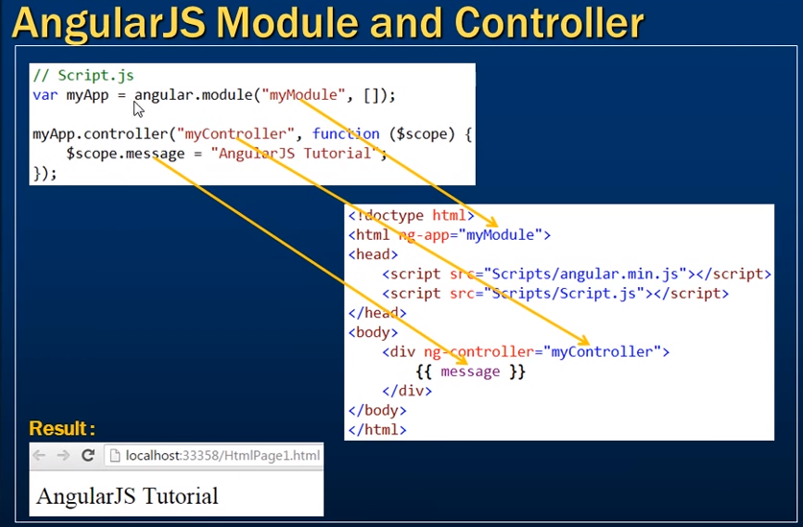

We have to add the behavior to the scope object.

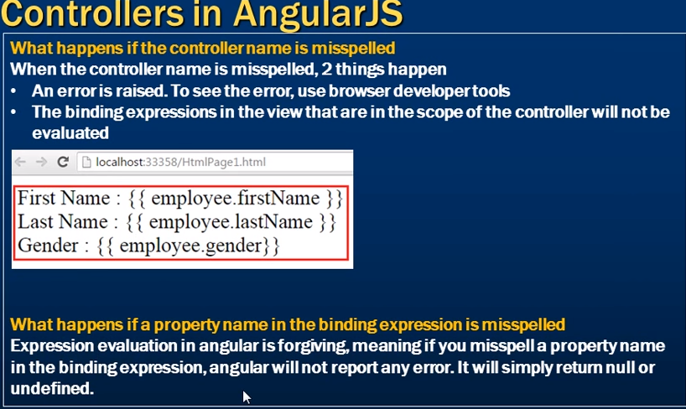

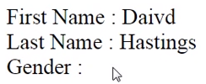

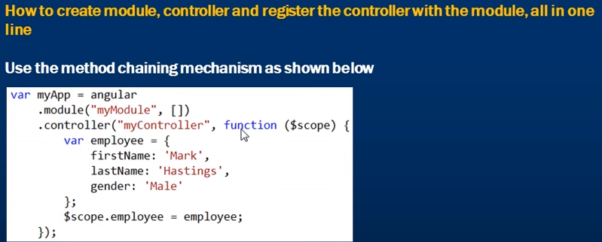

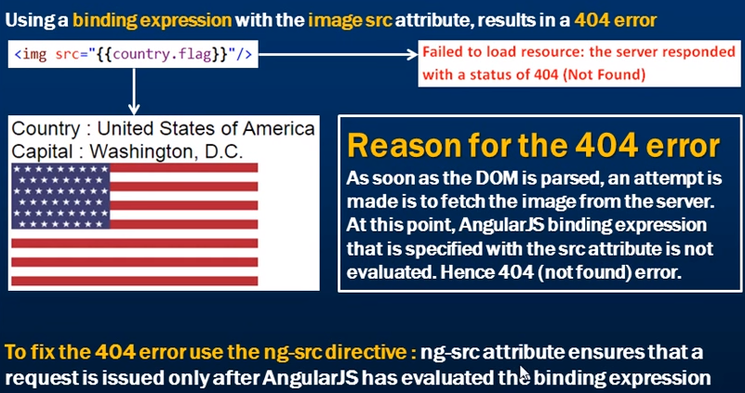

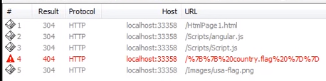

As soon as DOM is loaded the Angular js binding expression is not evaluated.

First request throws 404, then the second request will be made to fetch the image from the actual path. This will run in background. But the user may not aware of the second request made to load the image.

I guess, the binding expression is not evaluated at the first request, due to it is represented in double quotes.

Correct approach,

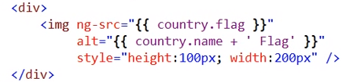

If the image is not found then the out,

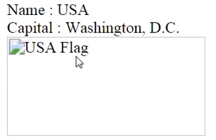

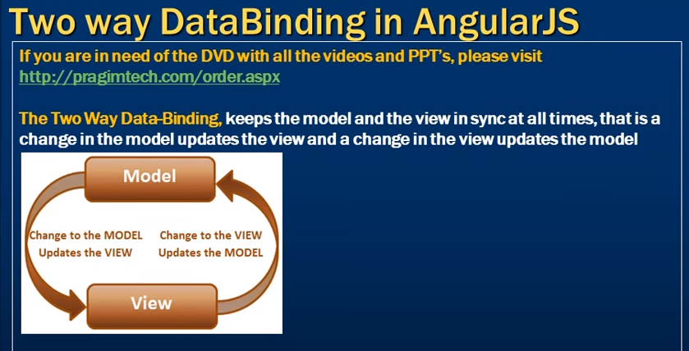

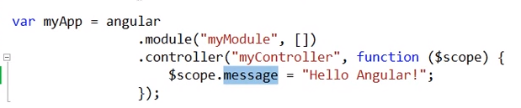

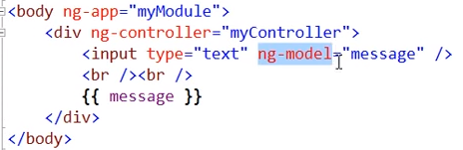

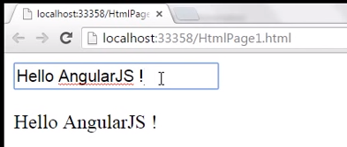



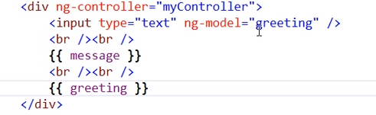

Angular will create the model ‘greeting’ behind the scenes. We haven’t created the model in the JS.

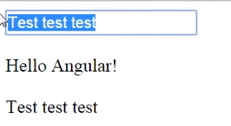

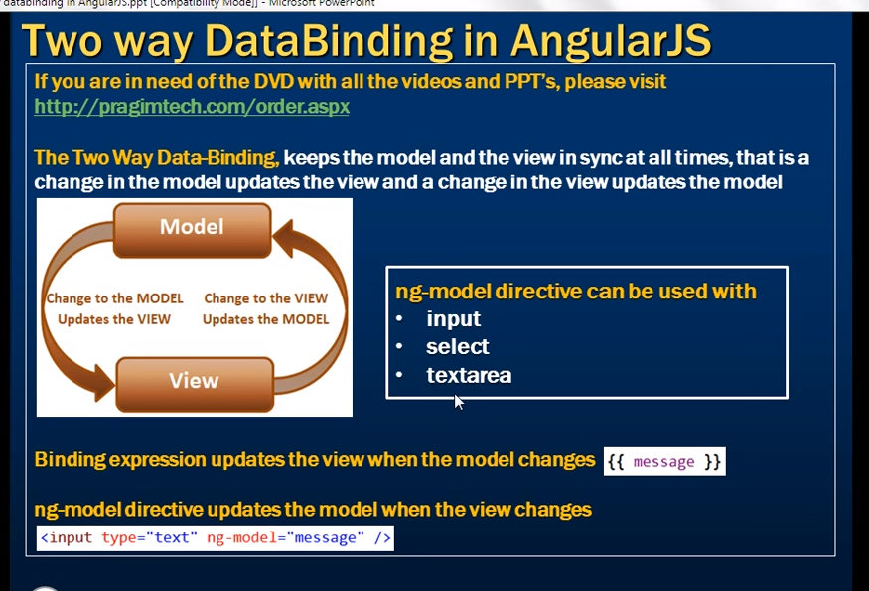

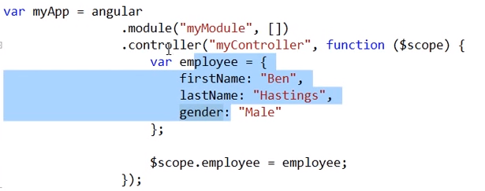

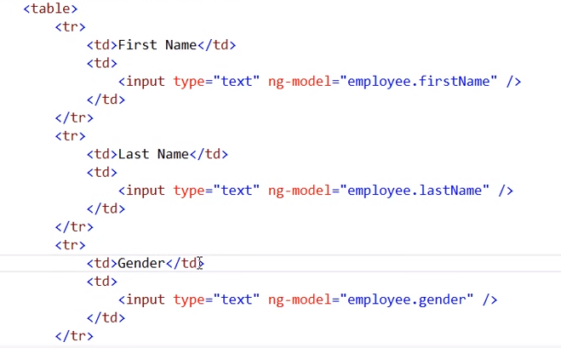

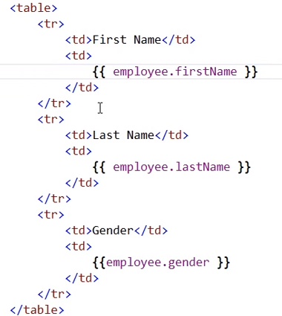

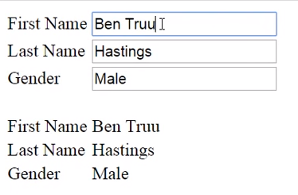

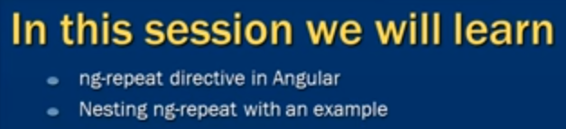

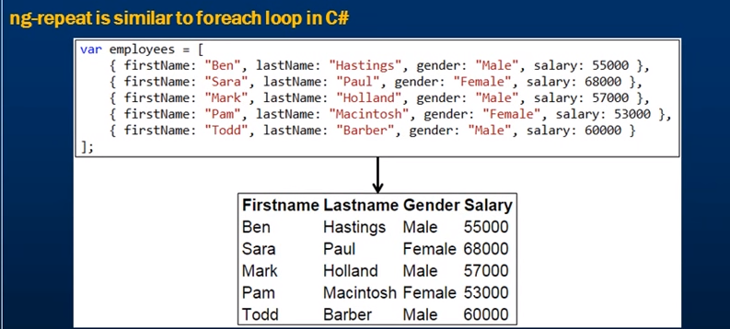

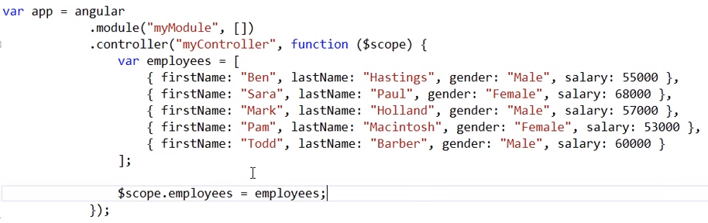

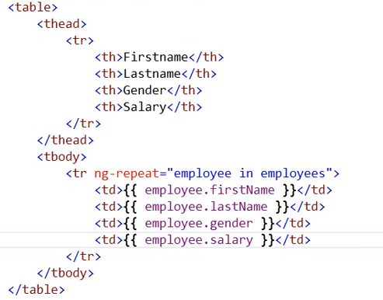

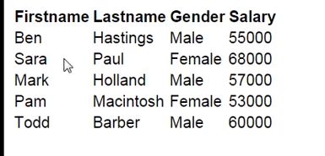

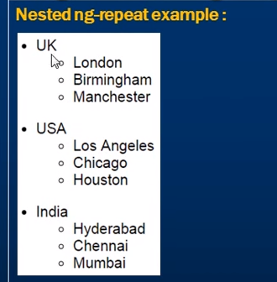

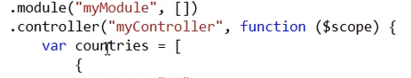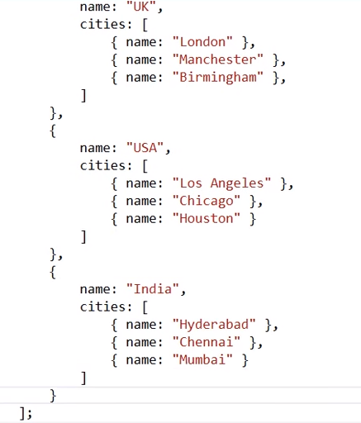

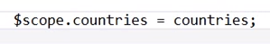

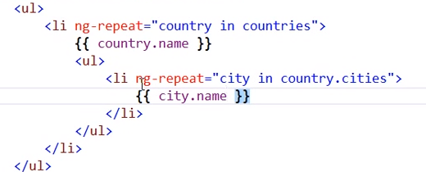

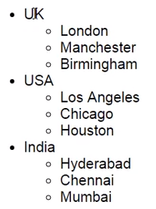

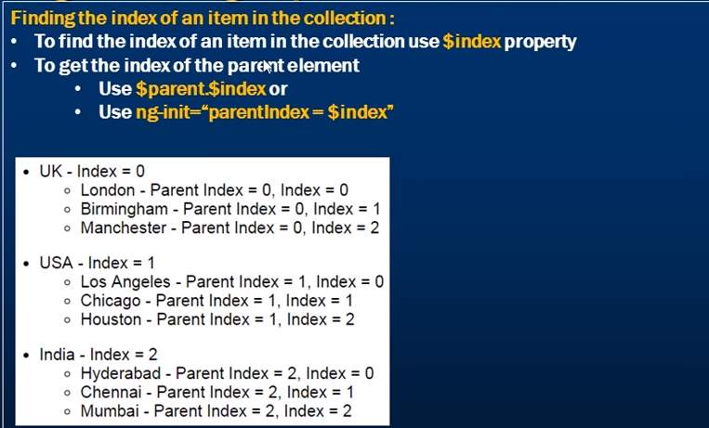

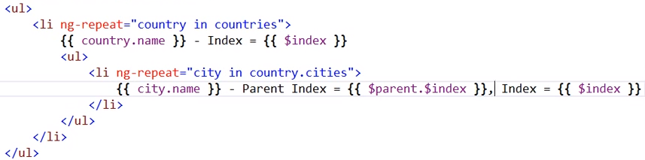

Or

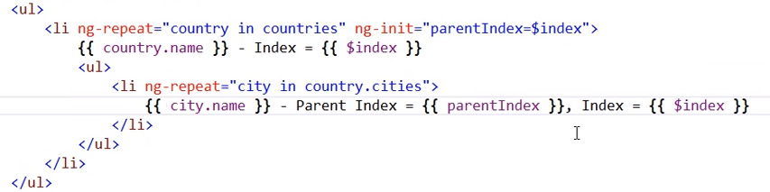

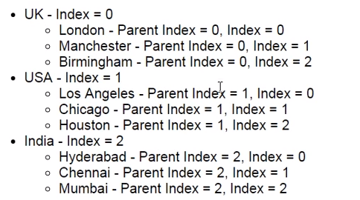

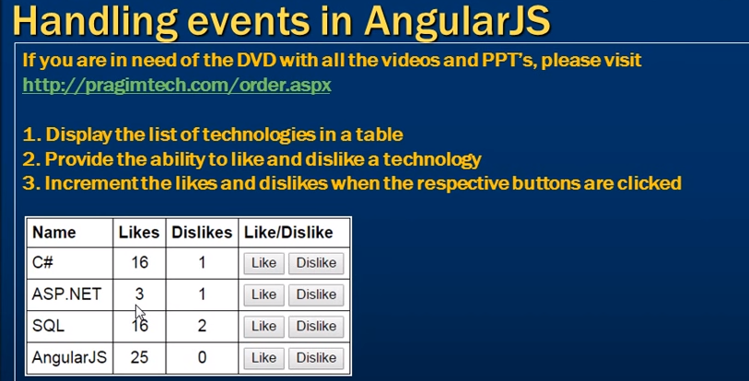

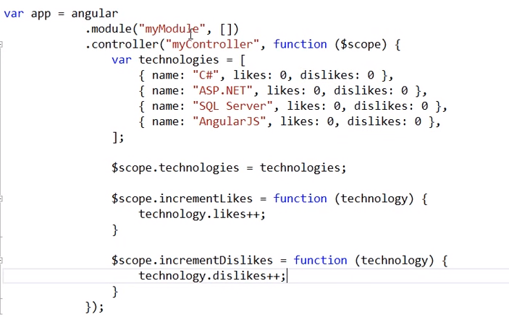

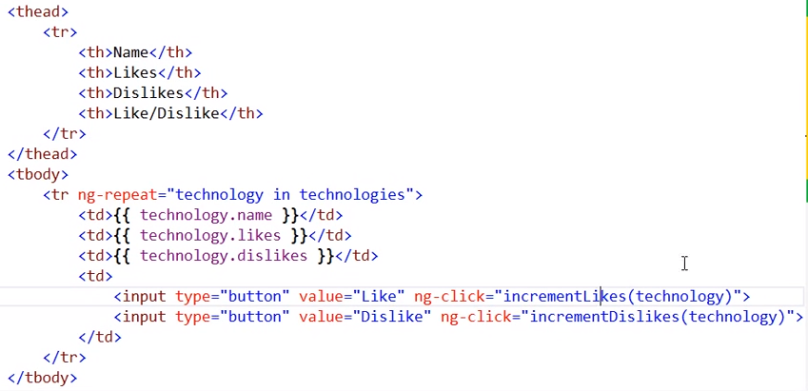

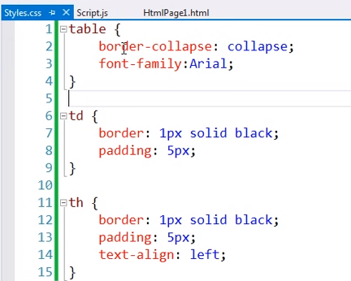

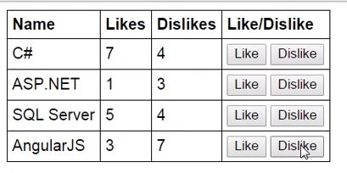

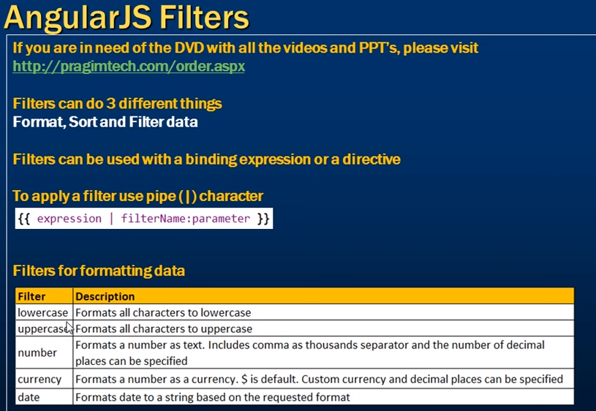

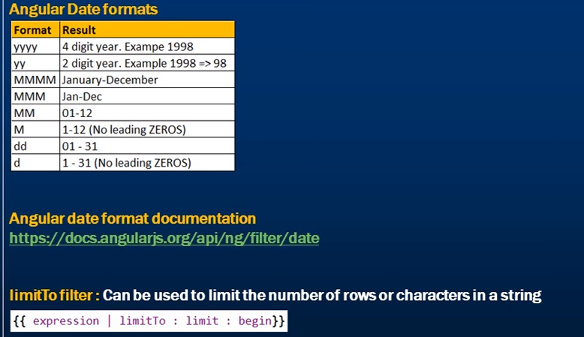

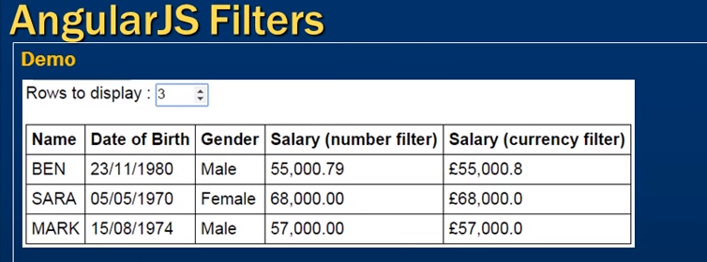

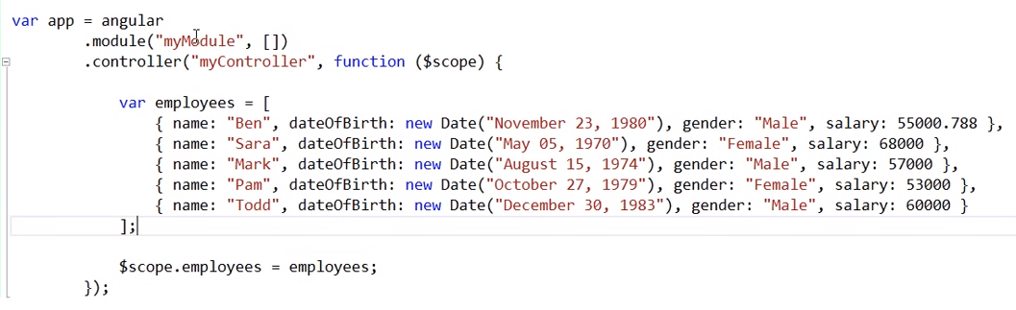

Default output:

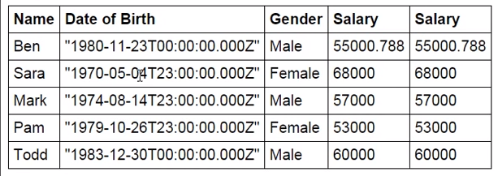

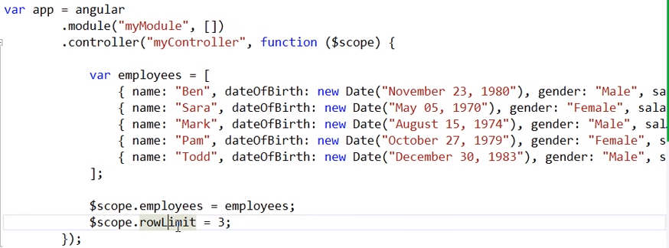

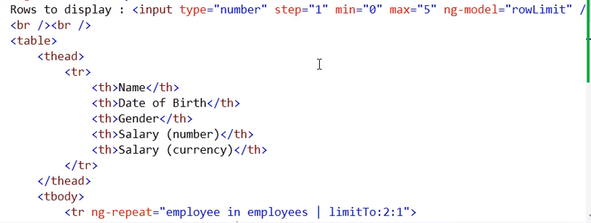

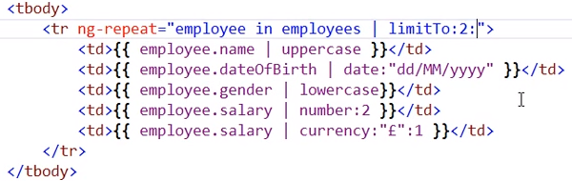

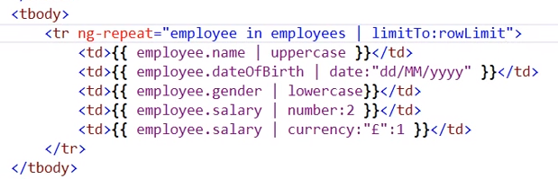

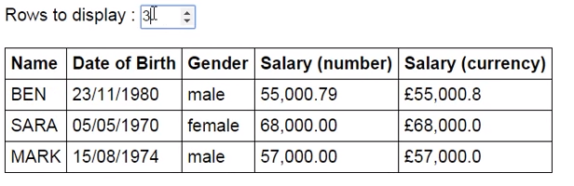

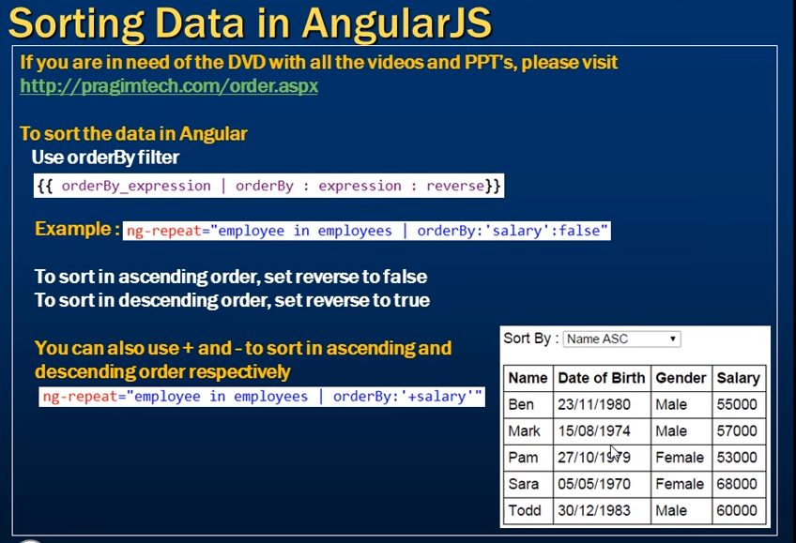

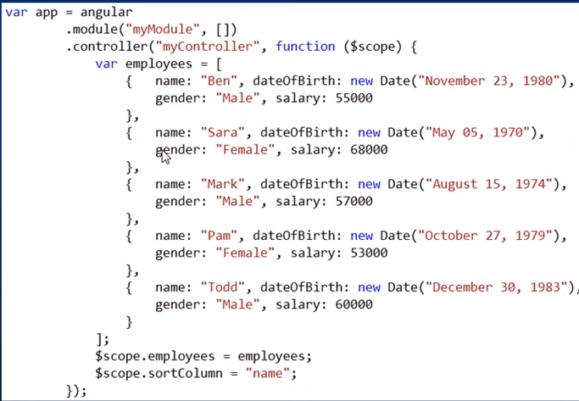

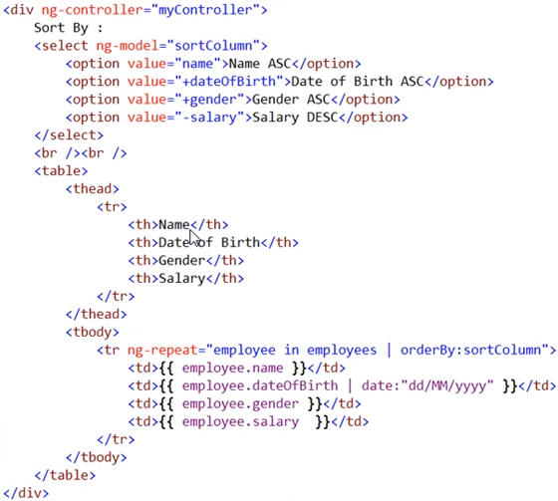

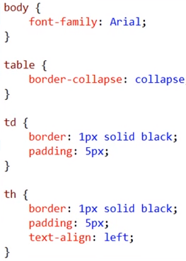

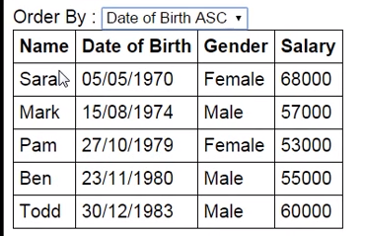

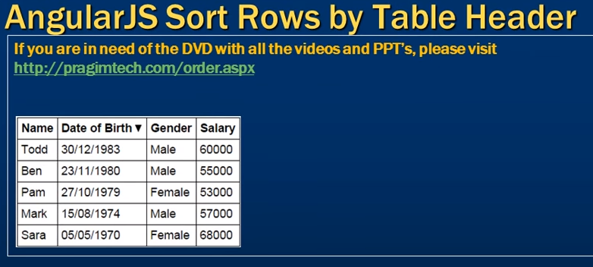

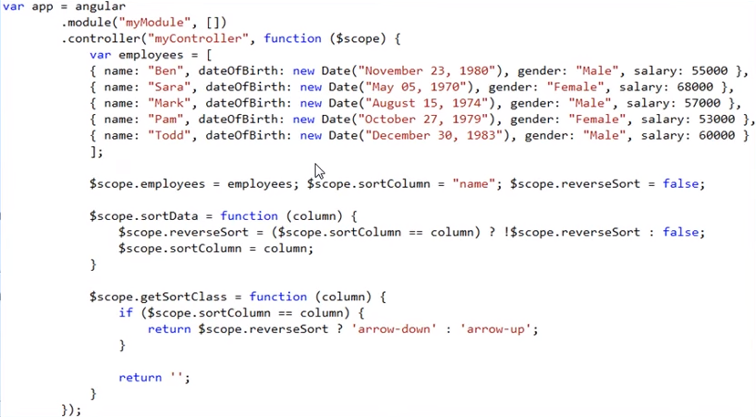

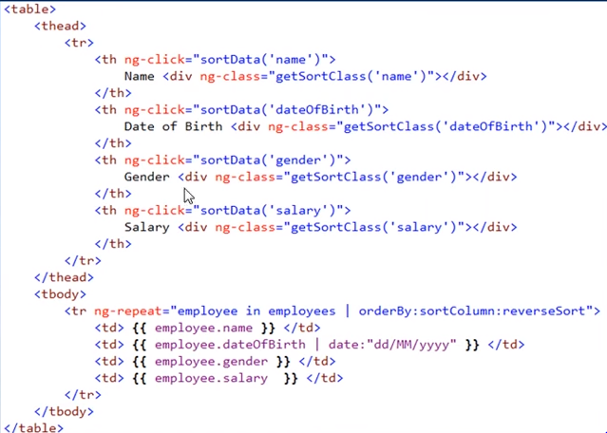

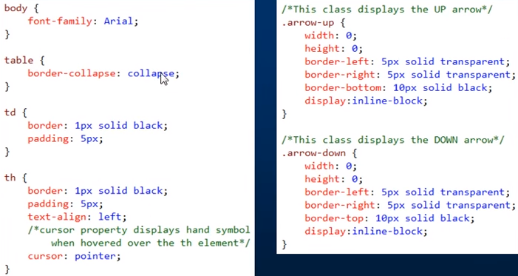

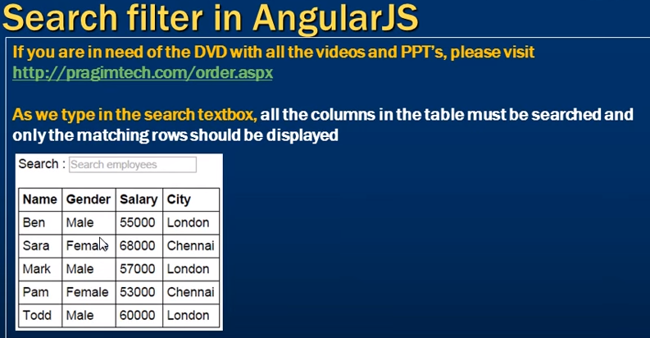

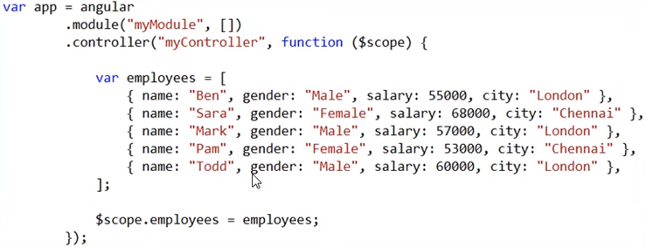

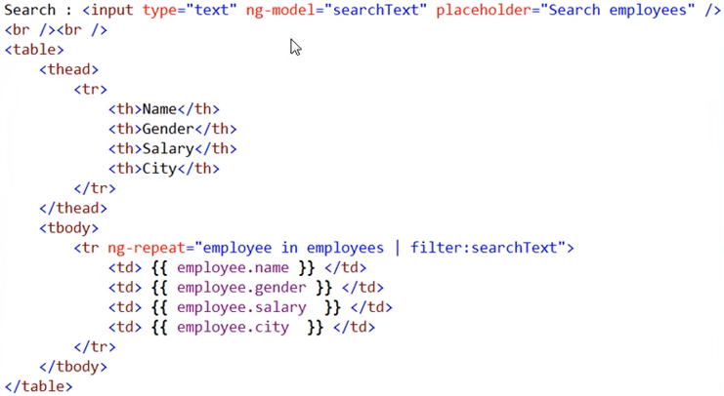

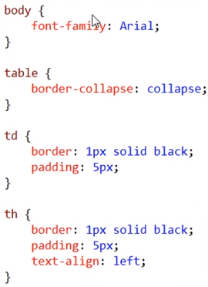

Note: searchText model is not placed in controller. Still it is working.

If we want to search only on particular column, following code will help. This is based on search from ‘city’.



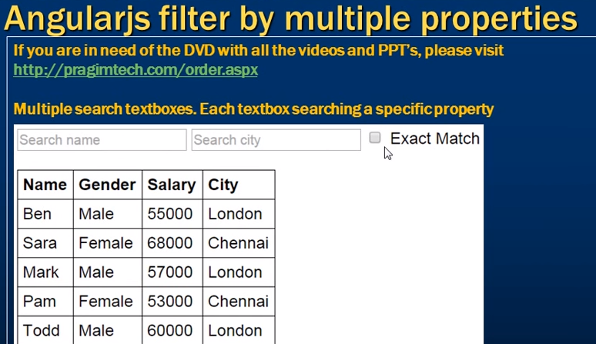

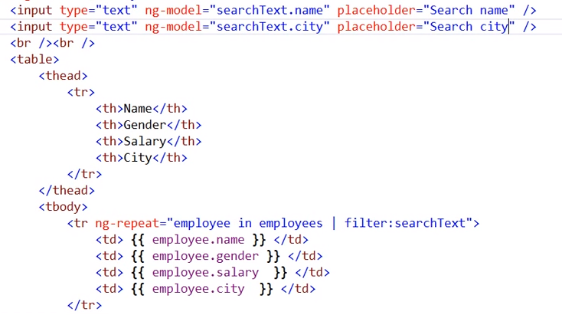

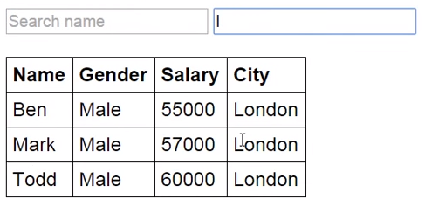

Now we can search using both name and/or city. Search is working together with name and city.

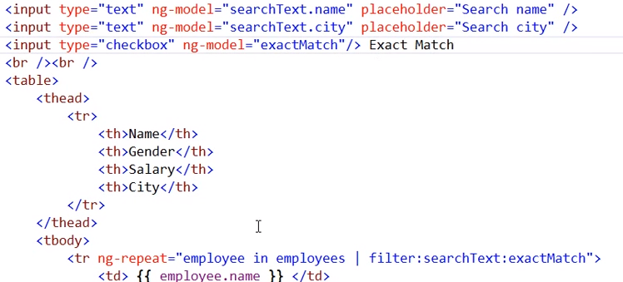

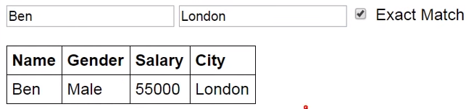

Here ‘exact match’ field value would be true or false. By default false. If it is false, when we type letter ‘L’, the record ‘London’ would be displayed. If it is true, the record ‘London’ would not be displayed until we type the text ‘London’ completely.

If we want to use the same text box for searching only based on few columns, we can use the below code. Here searching is happening based on columns ‘name’ and ‘city’.

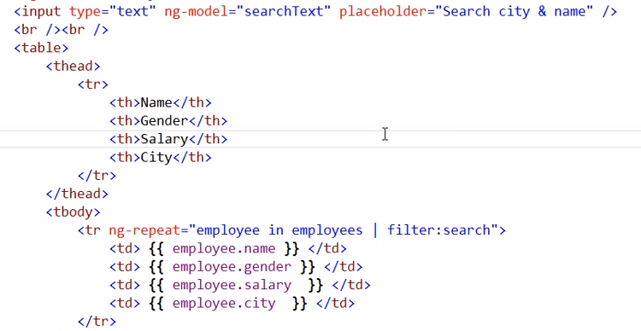

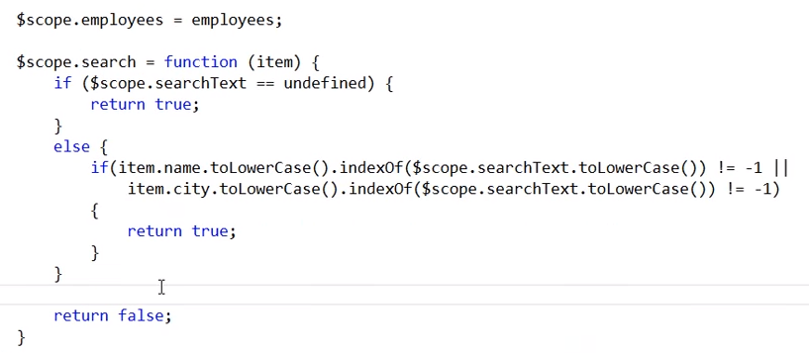

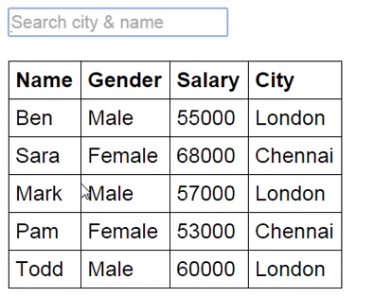

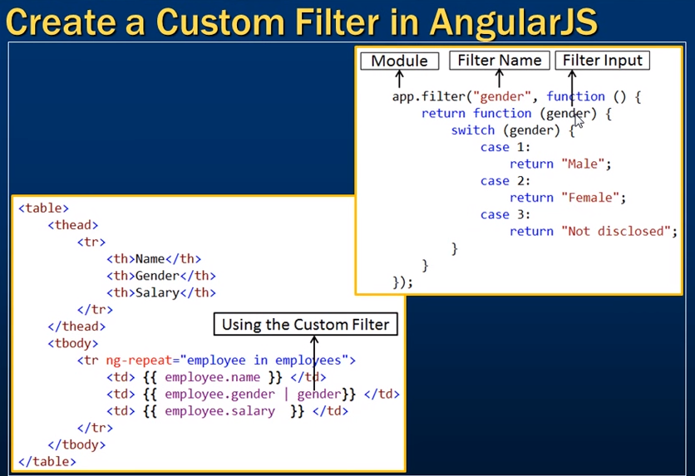

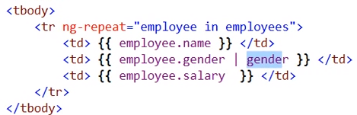

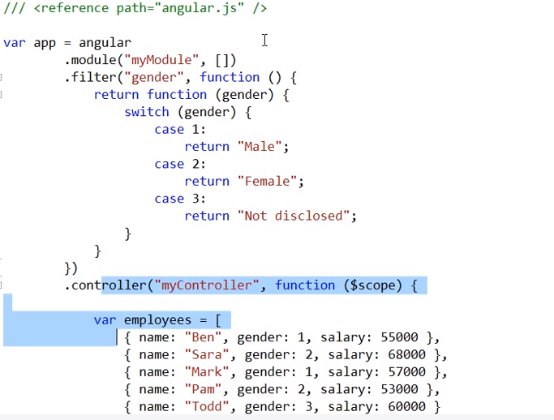

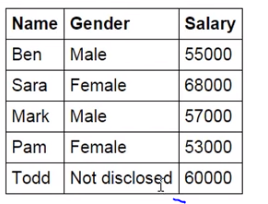

Writing filters code in a separate file (Filters.js)

Filters.js:

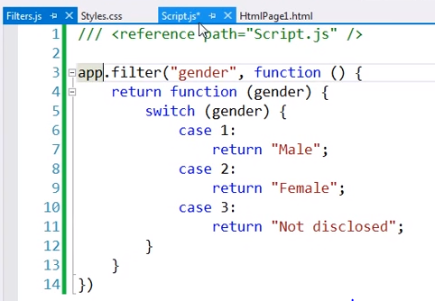

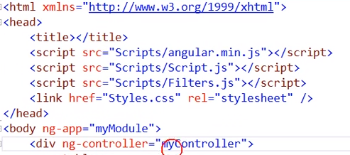

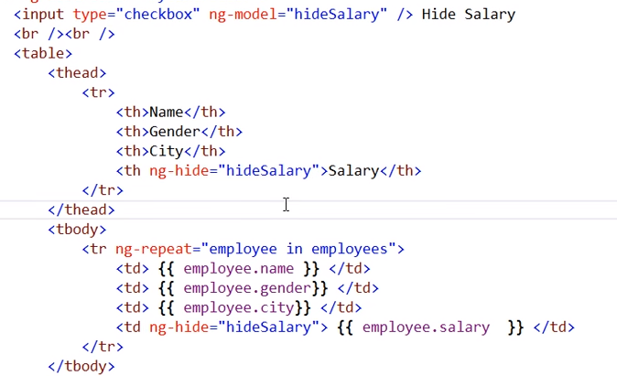

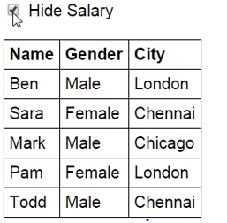

The above code and below one, both are giving same output.

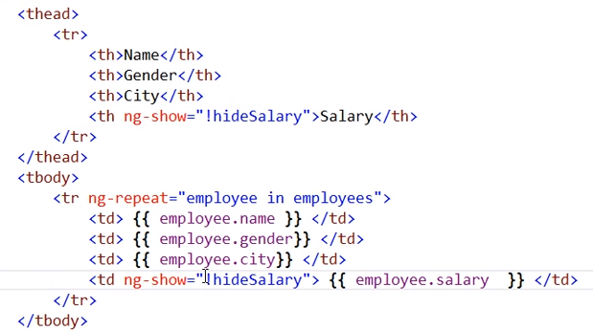

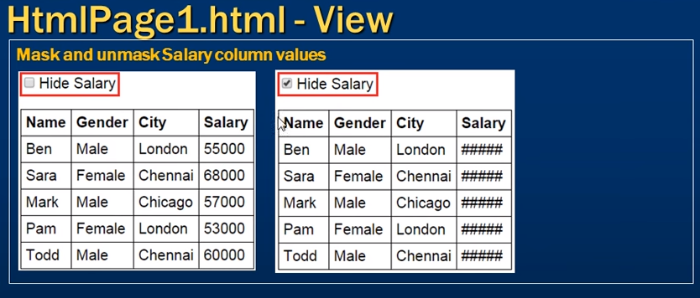

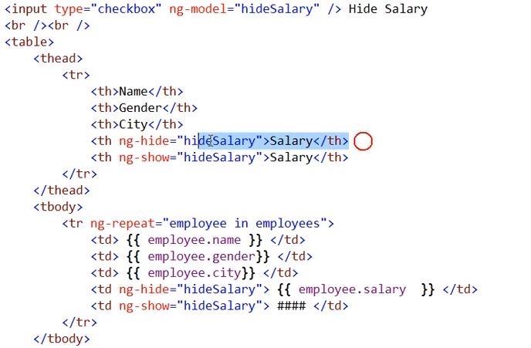

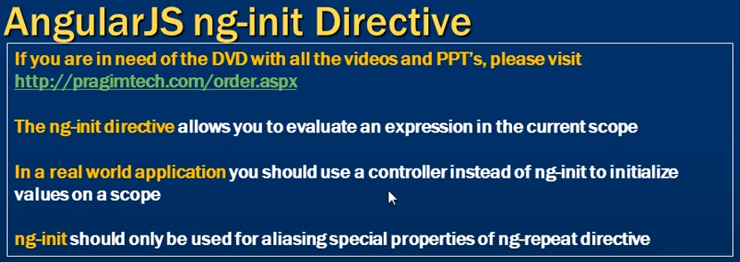

Special properties example, ‘$index’.

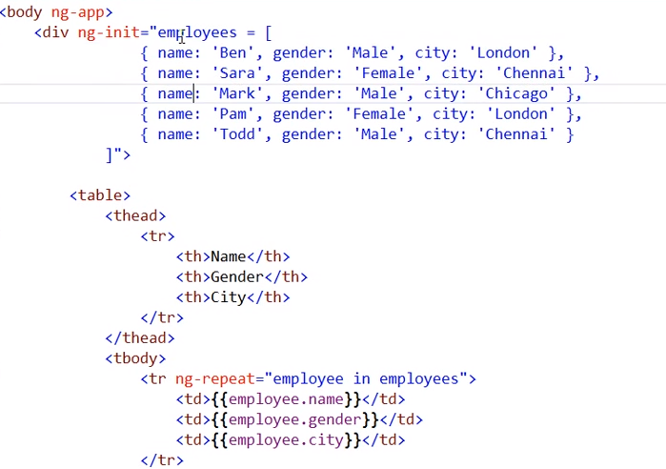

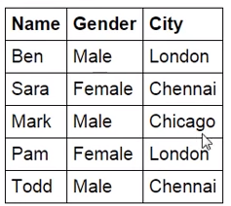

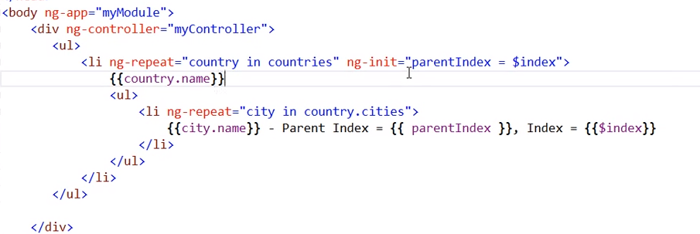

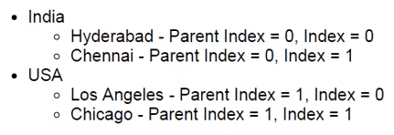

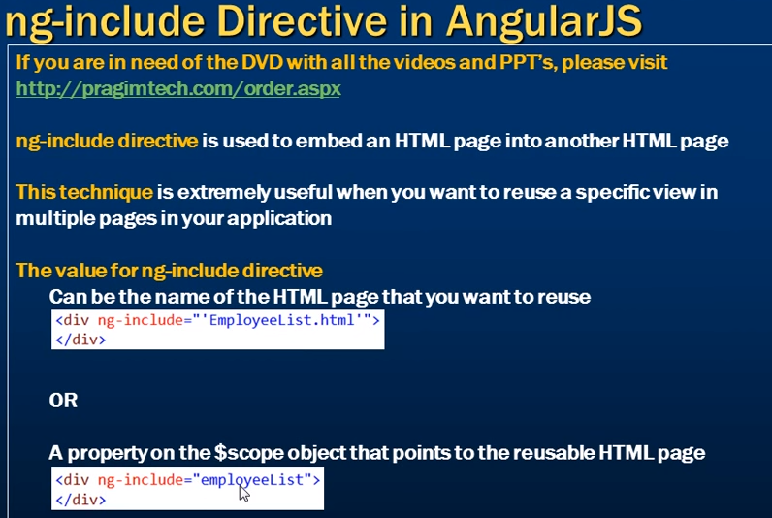

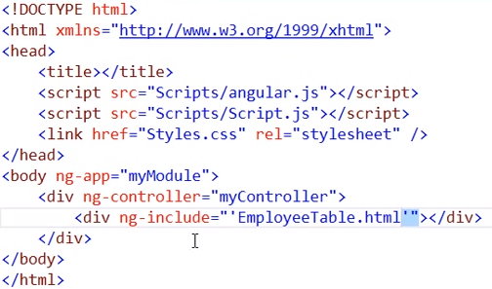

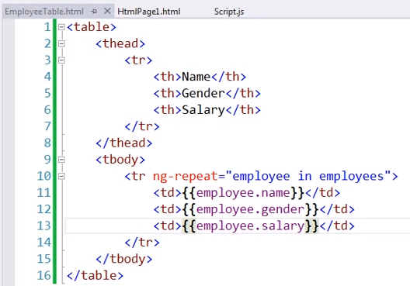

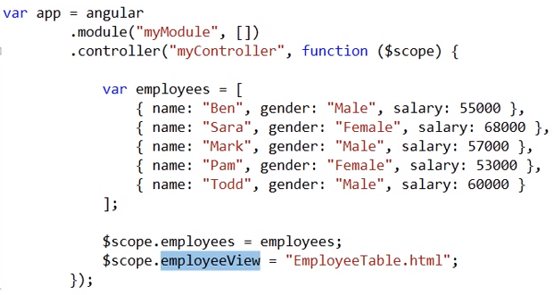

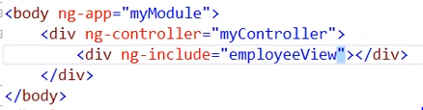

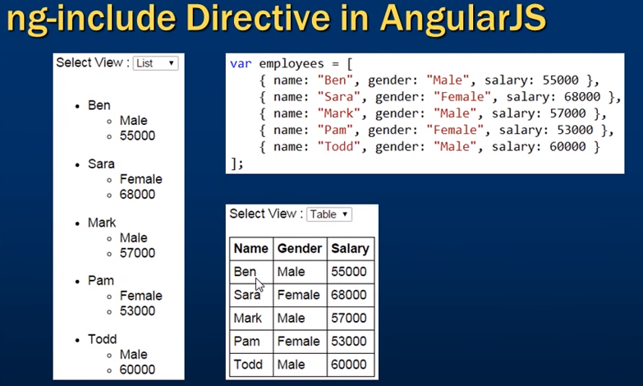

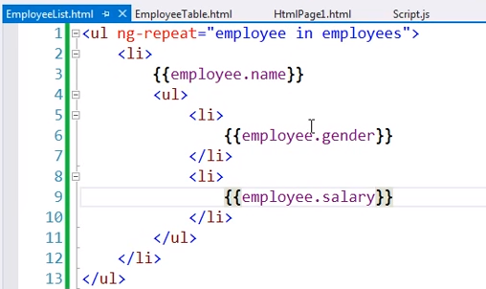

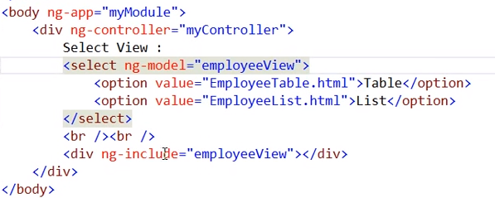

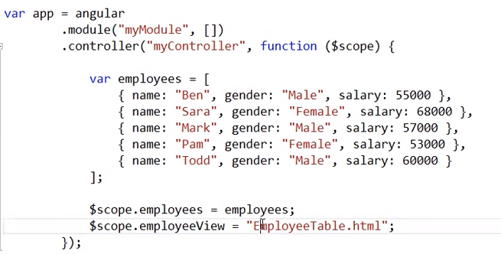

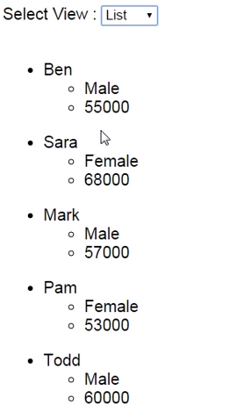

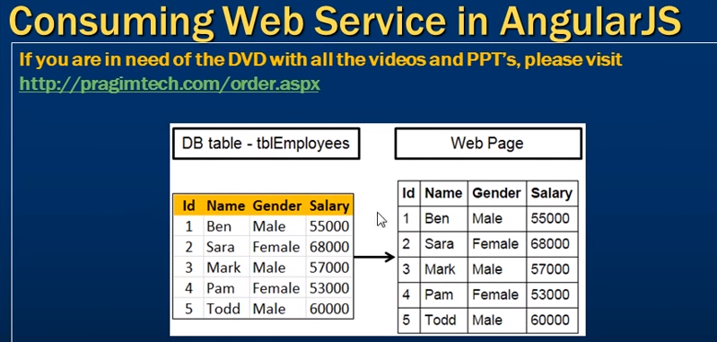

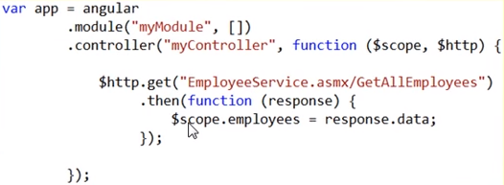

We can use $http.post also here.

Method returns (function returning) the value asynchronously. Meaning will not wait for response – Value will not be available immediately.

$http service provides AJAX service to the application.

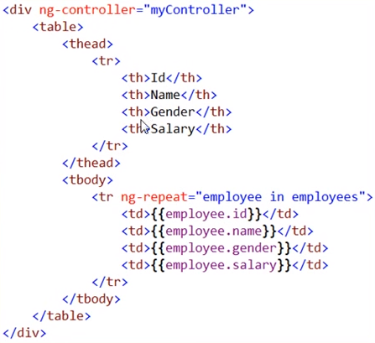

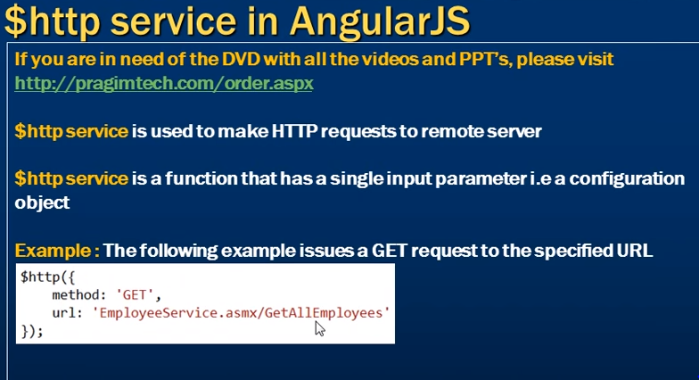

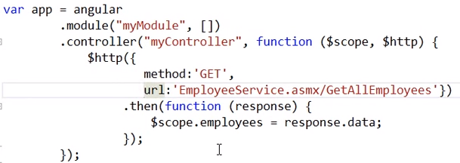

This code is giving the same output as above.

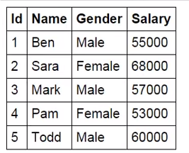

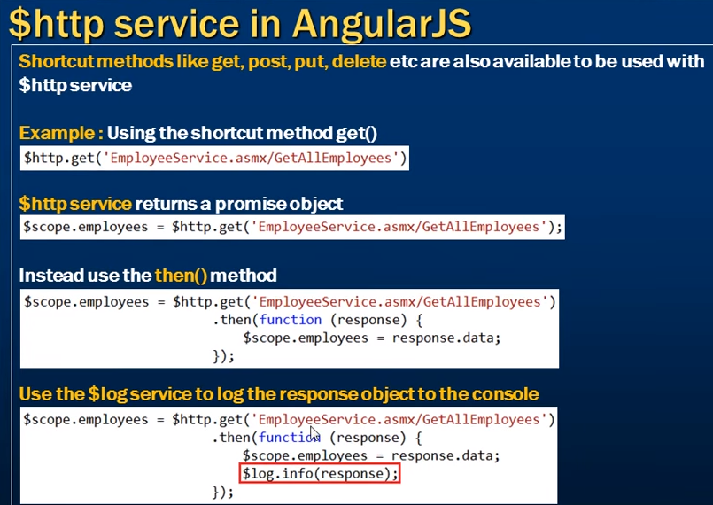

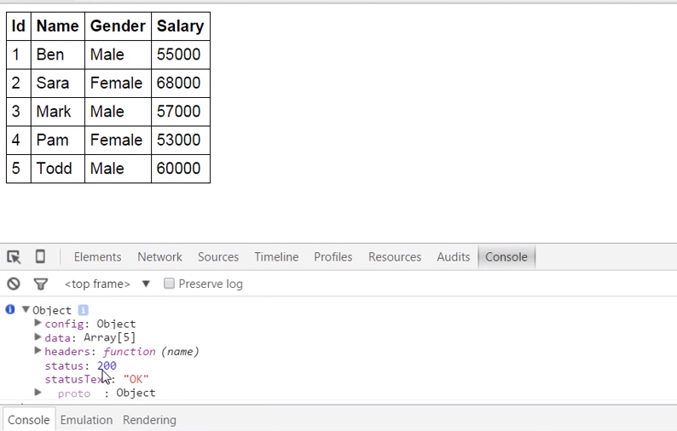

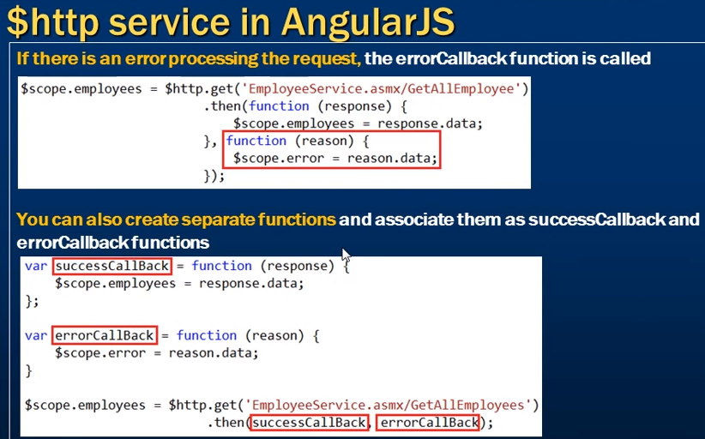

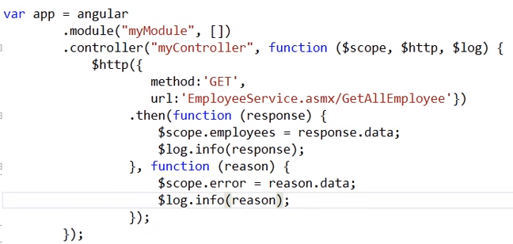

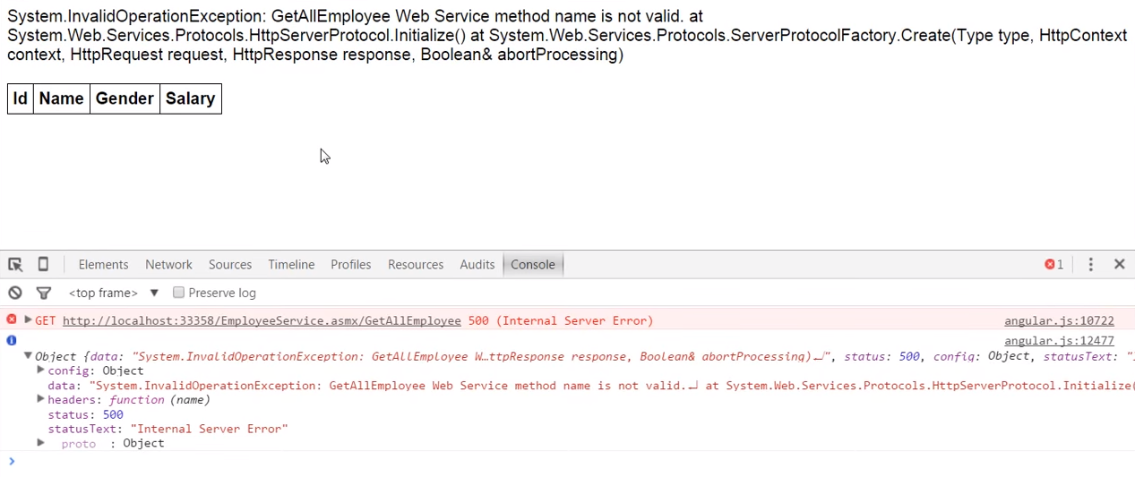

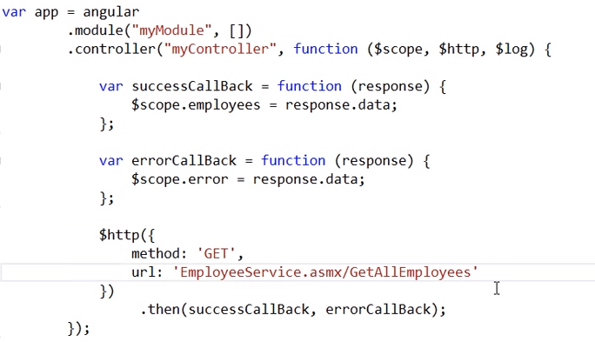

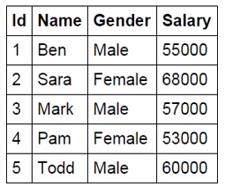

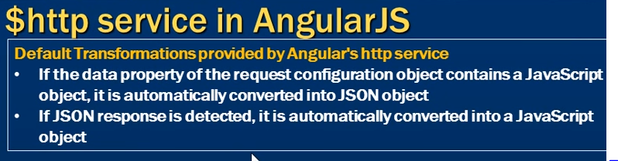

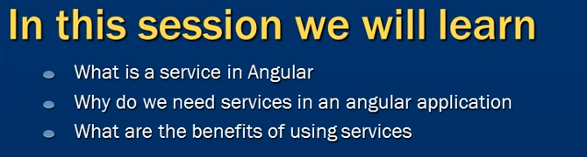

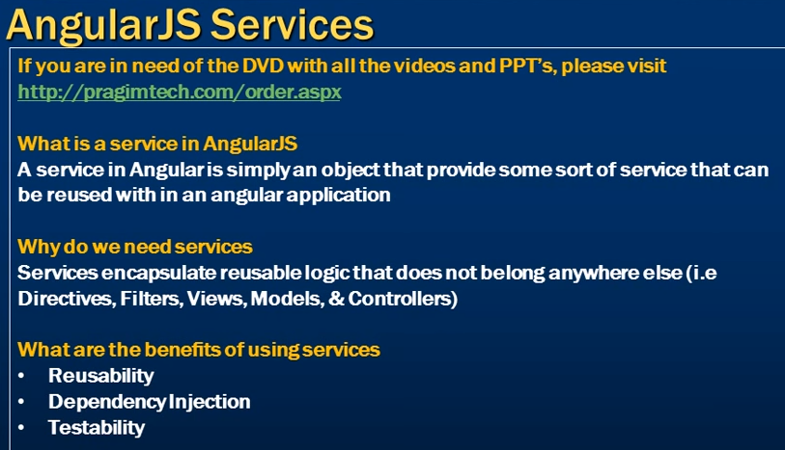



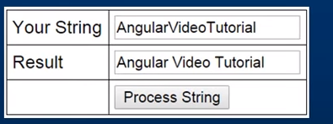

If we are not using service, we need to write the code in controller and it will not be reusable. Controller code will be complex and bit large. If we duplicating the code, the maintainability of the application gone for a toss. It looks clumsy.

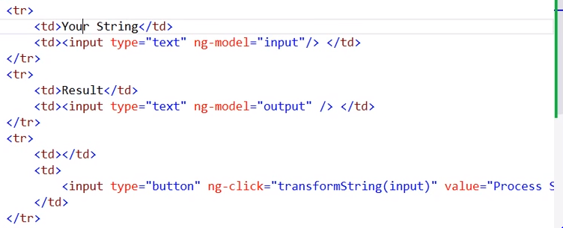

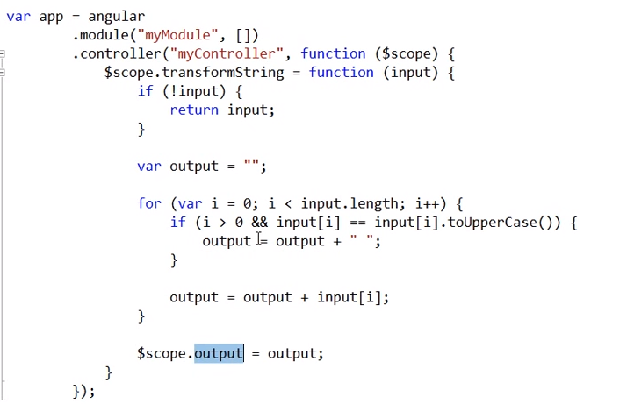

Factory method is used to create a custom service and register it with the angular.

Service in angular is a java script object with some properties and functions. Service in angular is stateless.

Service is ‘stringService’ and function is ‘processString’. In controller we have to inject the service ‘stringService’ and the function ‘processString’.

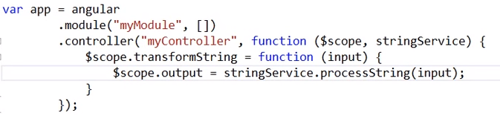

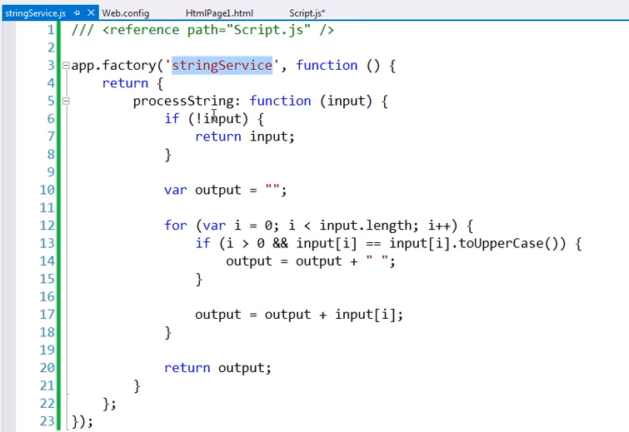

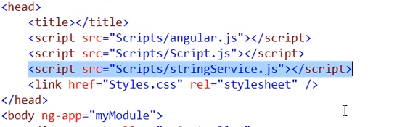

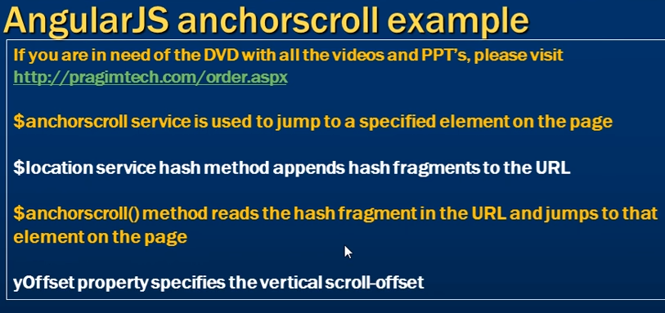

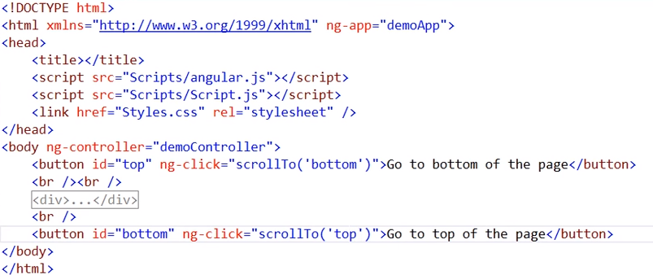

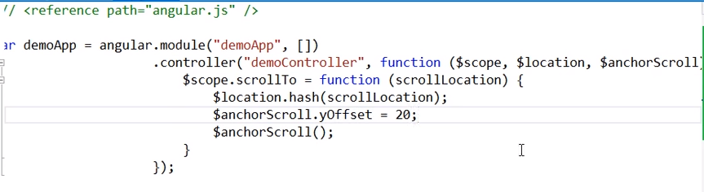

yOffset is used to keep the space in top.

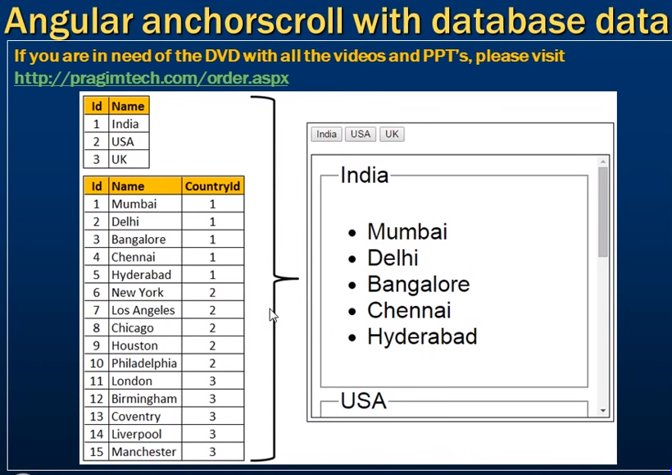

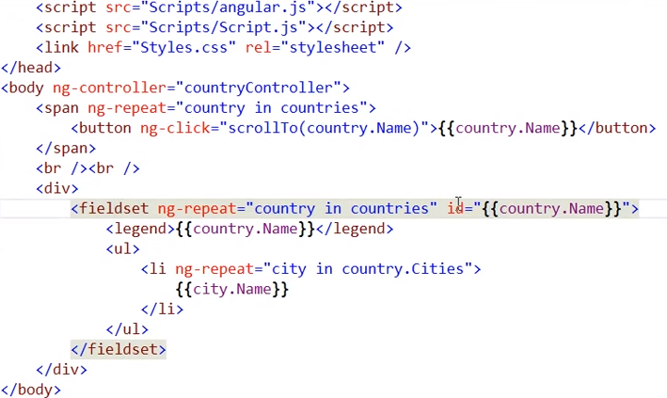

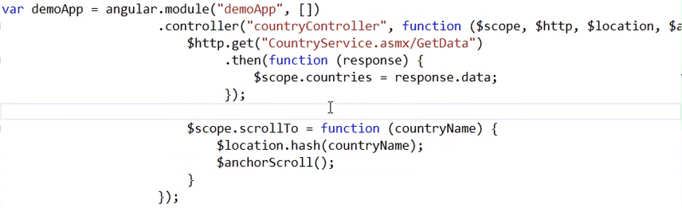

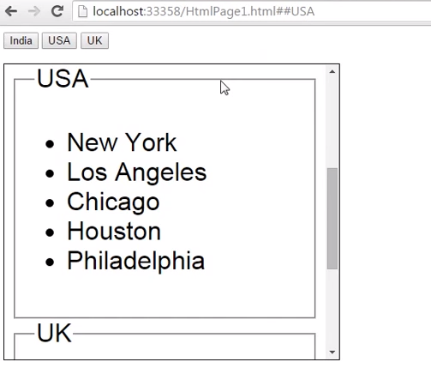

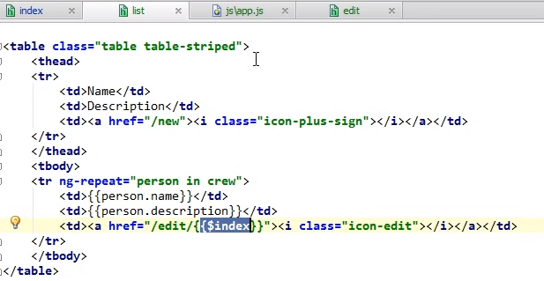

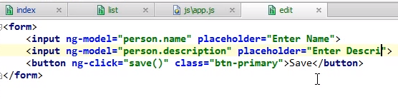

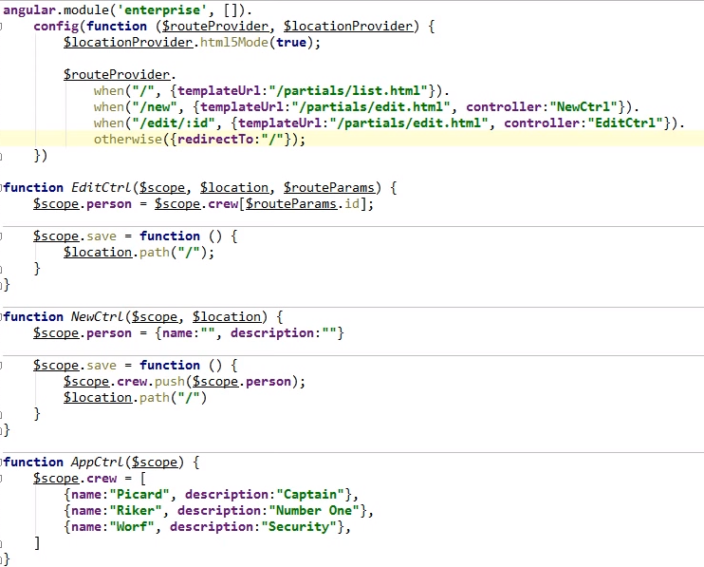

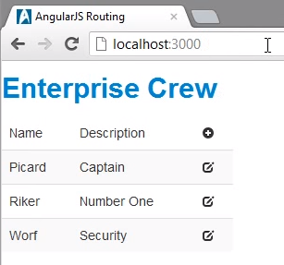

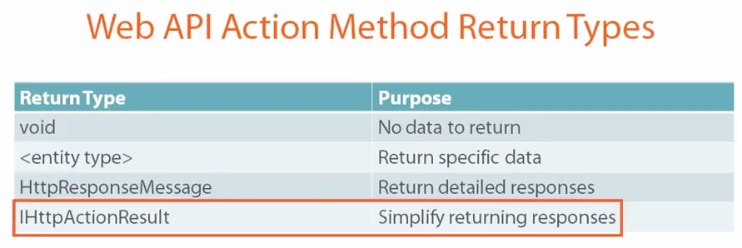

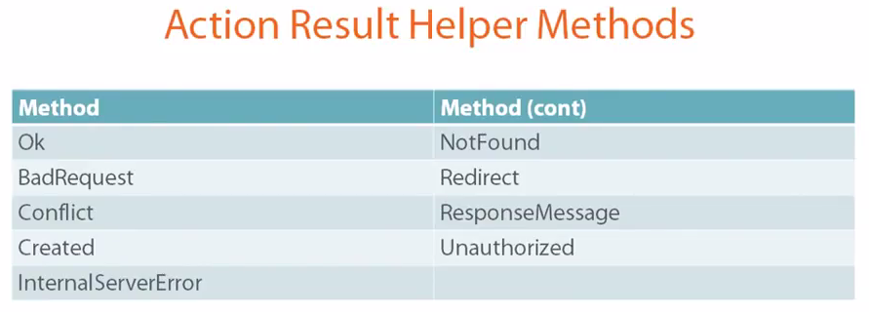

<https://www.youtube.com/watch?v=6DPQVaRRXpM>

Exceptions has to checked for

1. Database server down
2. No response from web service
3. No internet
4. Web server down
5. Null response from web service

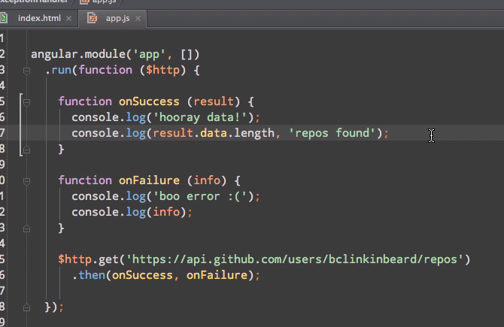

Result.count(); Here count is not a defined function. So exception will be raised. Angular needs to handle this exception. So we are using ‘$exceptionHandler’.

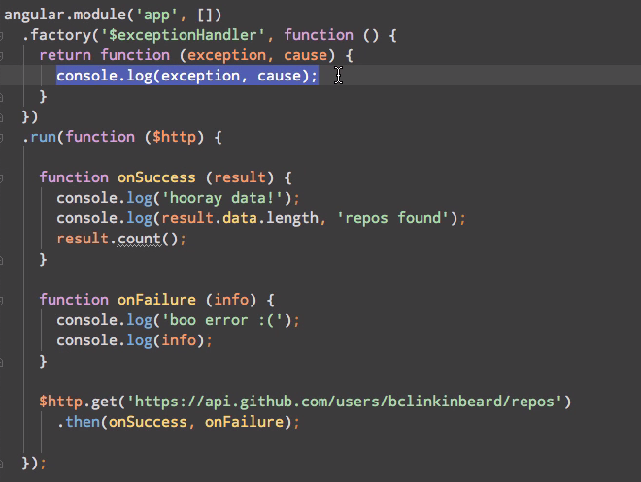

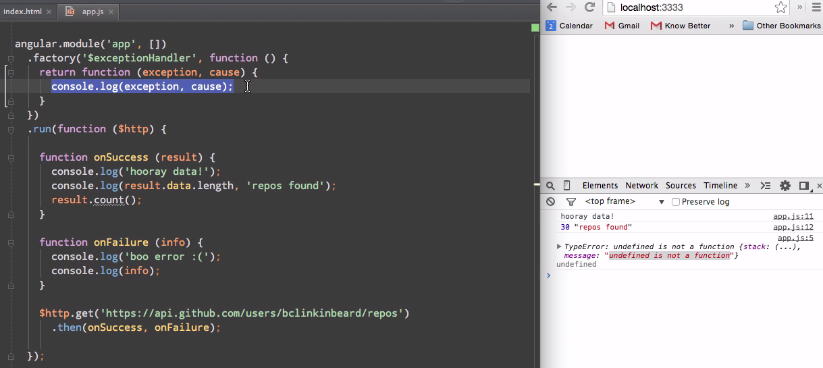

Cause is ‘undefined’, displaying in console.

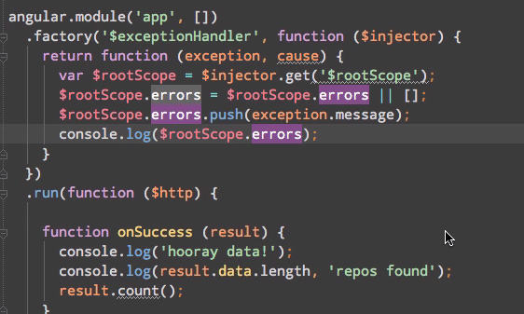

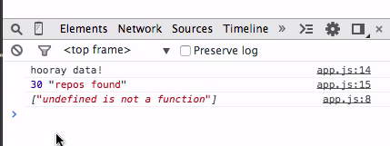

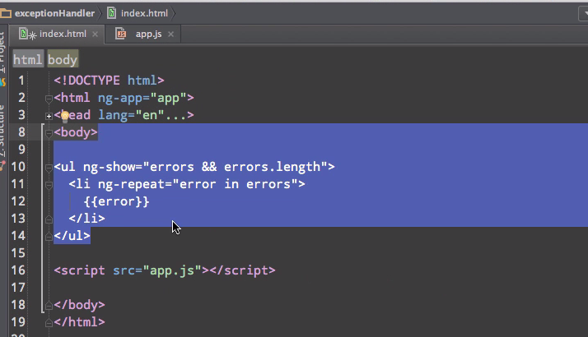

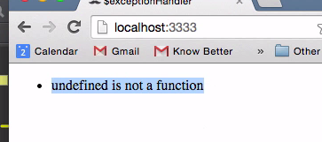

**If web service is responding properly**

console.log(response+'-'+response.statusText+'-'+response.status+'-'+response.data);

[object Object]-OK-200-

**If web service method name is wrong,**

response.statusText = ‘Not Found’; and response = ‘undefined’; response.data is throwing error – loading login page.

console.log(response+'-'+response.statusText+'-'+response.status+'-'+response.data);

**out:** [object Object]-Not Found-404-<html><head><title>Apache Tomcat/7.0.53 - Error report</title><style><!--H1 {font-family:Tahoma,Arial,sans-serif;color:white;background-color:#525D76;font-size:22px;} H2 {font-family:Tahoma,Arial,sans-serif;color:white;background-color:#525D76;font-size:16px;} H3 {font-family:Tahoma,Arial,sans-serif;color:white;background-color:#525D76;font-size:14px;} BODY {font-family:Tahoma,Arial,sans-serif;color:black;background-color:white;} B {font-family:Tahoma,Arial,sans-serif;color:white;background-color:#525D76;} P {font-family:Tahoma,Arial,sans-serif;background:white;color:black;font-size:12px;}A {color : black;}A.name {color : black;}HR {color : #525D76;}--></style> </head><body><h1>HTTP Status 404 - /newsletter/authenticate1/undefined/undefined</h1><HR size="1" noshade="noshade"><p><b>type</b> Status report</p><p><b>message</b> <u>/newsletter/authenticate1/undefined/undefined</u></p><p><b>description</b> <u>The requested resource is not available.</u></p><HR size="1" noshade="noshade"><h3>Apache Tomcat/7.0.53</h3></body></html>

**If web server is down:**

response.statusText = ‘’; - empty and response = ‘undefined’; response.data is throwing error – loading login page.

url: 'https://rcgsolutionsdemo1.cognizant.com/newsletter/authenticate/' + this.username + '/' + this.password

console.log(response+'-'+response.statusText+'-'+response.status+'-'+response.data);

**out:** [object Object]--0-null

Always we are getting the response object even the web service params (ip, method name) are wrong.

**If db server is down:**

In console, TypeError: Cannot read property 'subMenu' of null

Exercise:

try{

var a = b;

}catch(err) {

console.log(err.name+'-'+err.message);

alert(err.name+'-'+err.message);

}

.factory('$exceptionHandler', function($injector) {

return function(exception, cause) {

var $state = $injector.get('$state');

$state.go('mainState.genericexception',{"exceptionMessage":exception.message});

};

});

**Out:** ReferenceError – b is not defined

If we use try-catch block, $exceptionHandler will not be called. If we want to call $exceptionHandler manually, we can throw the exception using following syntax.

throw { message: err.message };

try{

var a = b;

}catch(err) {

throw { message: err.message };

}

If we want to print the exception in the currently displaying screen, we can use following syntax



If we caught the error manually, code in outside of catch block also will be executed. Else directly the $exceptionHandler will be called and it will display the exception message in screen.

If we have thrown the exception inside catch block, code in outside of catch block won’t be executed.

try{

var a = b;

}catch(err) {

alert(err.name+'-'+err.message);

}

alert('outside of try-catch block');

Here 'outside of try-catch block' message also will be displayed in alert.

If we are overriding '$exceptionHandler', the scope of '$exceptionHandler' will be applicable at module level. So '$exceptionHandler' will be called for the exceptions occurred in all the Controllers, Directives and Services associated with the module.

try {

var a = 5;

if(a>3) {

throw( new Error( "Something went boom."))

}

} catch (err) {

console.log(err+'-'+err.name + '-' + err.message);

alert(err+'-'+err.name + '-' + err.message);

}

If we throw the exception from try block, catch block will be called and output will be,

**Error: Something went boom.-Error-Something went boom.**

**Example implementation - Code:**

$http({

method: 'GET',

url: 'https://rcgsolutionsdemo.cognizant.com/newsletter/latesttrends/'+$scope.userId+'/'+$rootScope.regionName}).then(function successCallback(response) {

console.log('success -'+response+'-'+response.statusText+'-'+response.status+'-'+response.data);

$scope.latesttrends = response.data;

$ionicSlideBoxDelegate.update();

var isTrend = false;

if($scope.latesttrends.length >0) {

isTrend = true;

}

if(!isTrend) {

$scope.dataFoundTrend=false;

}

else {

$scope.dataFoundTrend=true;

}

}, function errorCallback(response) {

console.log('failure -' + response + '-' + response.statusText + '-' + response.status + '-' + response.data);

var excMessage = response.statusText;

if (response.status == 0) {

excMessage = 'Web server is down..'

}

throw { message: excMessage };

});

**From spring throwing the exception message:**

An exception for a missing order.

@ResponseStatus(value=HttpStatus.NOT_FOUND, reason="No such Order") // 404

public class OrderNotFoundException extends RuntimeException {

// ...

}

**Controller:**

@RequestMapping(value="/orders/{id}", method=GET)

public String showOrder(@PathVariable("id") long id, Model model) {

Order order = orderRepository.findOrderById(id);

if (order == null) throw new OrderNotFoundException(id);

model.addAttribute(order);

return "orderDetail";

}

**Correctly throwing an error**

Two tips on throwing an error:

**1:** Always throw an instance of Error class, never throw a string or an object. Getting stack trace is only possible via Error object, for example.

**throw** **new** Error('broken') *// good*

**throw** 'broken' *// bad*

**2:** Throwing an error stops code execution. If the error is not serious enough, throw it asynchronously

**if** (!some_condition) {

setTimeout(**function** () {

**throw** **new** Error('some_condition failed!');

}, 0);

}

You could even create a utility function for this purpose

**function** asyncThrow(err) {

**if** (!(err **instanceof** Error)) {

**throw** **new** Error('please throw only instance of Error, not ' + err);

}

setTimeout(**function** () { **throw** err; }, 0);

}

**if** (!some_condition) {

asyncThrow(**new** Error('some_condition failed!'));

}

### GOALS

Single page application

No page refresh on page change

Different data on each page

### AngularJS Expressions vs. JavaScript Expressions

Like JavaScript expressions, AngularJS expressions can contain literals, operators, and variables.

Unlike JavaScript expressions, AngularJS expressions can be written inside HTML.

AngularJS expressions do not support conditionals, loops, and exceptions, while JavaScript expressions do.

AngularJS expressions support filters, while JavaScript expressions do not.

### AngularJS Modules

An AngularJS module defines an application.

The module is a container for the different parts of an application.

The module is a container for the application controllers.

Controllers always belong to a module.

var app = angular.module(**"myApp"**, []);

The [] parameter in the module definition can be used to define dependent modules.

Without the [] parameter, you are not creating a new module, but retrieving an existing one.

<form ng-app="" name="myForm">  
    Email:  
    <input type="email" name="myAddress" ng-model="text">  
    <span ng-show="myForm.myAddress.$error.email">Not a valid e-mail address</span>  
</form>